Role of Computed Tomography Angiography (CTA) In The Diagnosis Of Coronary Artery Anomalous Origins and Extracardiac Vascular Malformation Of Congenital Heart Disease In Pediatric Age Group

Hend Gamal Abd El-moneim El-zeir,Msc
Department of radiology
Benha University
Egypt
hindgamila@gmail.com

2-Hesham El sayed El Sheikh , MD
Department of radiology
Benha University
Egypt

3- Hadeel Mohamed Seif El Dien,
Department of radiology,
Cairo University
Egypt

4- Basem Mofreh Mahmoud Aglan
Department of cardiothoracic surgery
Benha University
Egypt

5-Dr/Amr Essam Abdel Mageed Abd-Allah
Radiology consultant
AL-NAS hospital
Egypt

Abstract:
Background:
Preoperative diagnosis of extra-cardiac malformations is essential for surgical planning. Computed tomography (CT) cardiac angiography plays an essential role in CHD, especially for assessing the extra-cardiac manifestations of CHD. Complex cardiovascular anatomic features and extra-cardiac manifestations identified with CT angiography(CTA) are sometimes more useful in decision-making in surgical procedures,this study aimed to detect the role of CT angiography in diagnosis of coronary artery anomalous origins and extracardiac vascular malformation of congenital Heart disease in pediatric age group
Methods:
- This prospective study was conducted in the Department of Radiodiagnosis at Benha university hospital Cases were selected randomly from Pediatric patients with known congenital cardiac disease for whom echo were referred to CT cardiac angiogram for extracardiac anomalies work up in the department of jan 2021 to may 2024, 50 consecutive patients (male 23, female 27); with age ranging from 4 months to 11 years were diagnosed with congenital complex cardiac malformations on clinical assessment or echocardiography with suspected intrathoracic extra-cardiac vascular anomalies, All the angiogram was done with All CT examinations were performed using Multi Detector CT(MDCT )(GE 128 slice CT scan).
Results:
Regarding CT findings, patent ductus arteriosus (PDA) emerged as the most frequently observed anomaly, accounting for 20% of cases, followed by coarctation of aorta (16%)MAPCAS (14%) and,, PAPVR (14%), , transposition of the great arteries (10%), DORV (8%), right-sided aortic arch (10%), and double superior vena cava (10%).
Less frequently encountered anomalies included anomalies in the origin of coronary arteries represented (6%), , hypoplastic aortic arch (12%), , interrupted aortic arch (8%), TAPVR (8%), aberrant left subclavian artery (6%), pseudocoarctation (4%), truncus arteriosus (4%), double aortic arch (4%),

Conclusion: Multislice CT angiography (MSCTA) is helpful in accurate diagnosis of confident diagnosis and anatomic detection of extra-cardiac vascular abnormalities and coronary arteries anomalous origin compared with echocardiography.

Key words: computed tomography,extracardiac vascular malformation,paediatrics,congenital heart disease.
Abbreviations:

CT, Computed tomography ; CTA, CT angiography ; CHD, congenital heart disease; MDCT, Multi Detector CT ; PDA, Patent ductus arteriosus ; PAPVAR, partial anomalies pulmonary venous return ; TAPVR, Total anomalies pulmonary venous return ; IAA, interrupted aortic arch; MSCTA, Multislice CT angiography ; SVC,superior vena cava; MAPCAS major aortopulmonary collaterals ; MPA, main pulmonary artery ;TGA,transposition of great vessels , DORV ,double outlet right ventricle; TTE, trans thoracic echocardiography.

Introduction:

CHDs are a heterogeneous group of diseases that include a wide spectrum of conditions and sub-conditions, for which the treatment approach varies widely (1). About one-fourth of these suffer from critical heart disease requiring early intervention within the 1st year of life. Hence, the diagnosis of congenital malformations early in life is essential for the survival of a child with critical cardiac disease (2).
Comprehensive anatomic assessment in complex CHD is crucial for adequate patient management. Trans-thoracic echocardiography (TTE) along with cardiac catheterization serves as the cornerstone modalities in complex CHD primary evaluation. A high proportion of extracardiac vascular and non- vascular malformations are peculiar for CHD. Those further common abnormalities may influence the precise planning of corrective or palliative surgical or non-surgical therapy. In patients with complex CHD, TTE with color Doppler provides excellent delineation of the intracardiac anomalies comprising hemodynamic evaluation as well. However, TTE had less accuracy in characterizing extra cardiac thoracic structures like the aorta and the aortic arch branches, the pulmonary arteries and their branches, the pulmonary veins, or associated other vascular structures and airways (3).
The capability of electrocardiography-gated computed tomography-angiography (ECG-gated CTA) to accurately volumetrically image the morphologic features of complex CHD has been well portrayed in adults and young patients (4) . Moreover, retrospectively ECG-gated helical CT Congenital Extra-Cardiac Vascular Anomalies permits both morphologic and functional evaluation of the heart as hemodynamic information, comprising extra-cardiac and intracardiac shunts as well as valvular diseases; however this in return for higher radiation dose compared to prospective ECG-gated sequential scans (5). It also enables the systematic evaluation of other thoracic structures like cardiovascular structures, the airways and the lungs by using maximum and minimum intensity projections to delineate the vascular and airway structures, respectively. Extra-cardiac great vessels can be evaluated along their length; thus augmenting the role of cardiac CT scans in children with congenital heart diseases (3).

Aim of the work:
To detect the role of CT angiography in diagnosis of coronary artery anomalous origins and extracardiac vascular malformation of congenital Heart disease in pediatric age group

PATIENTS AND METHODS:

- This prospective study was conducted in the Department of Radiodiagnosis at Benha university hospital Cases were selected randomly from Pediatric patients with known congenital cardiac disease for whom echo were referred to CT cardiac angiogram for extracardiac anomalies work up in the department of jan 2021 to may 2024, 100 consecutive patients (male 52, female 48); with age ranging from 4 months to 11 years were diagnosed with congenital complex cardiac malformations on clinical assessment or echocardiography with suspected intrathoracic extra-cardiac vascular anomalies, All the angiogram was done with All CT examinations were performed using Multi Detector CT(MDCT )(GE 128 slice CT scan).Cases were selected randomly from Pediatric patients with known congenital cardiac disease for whom echo were referred to CT cardiac angiogram for cardiac and extracardiac anomalies work up in the department of radiodiagnosis at Benha university hospital.
- Inclusion criteria
Patients with an age up to 18 years old,All the cases with known pediatric congenital cardiac anomalies were diagnosed and screened by echocardiogram,No gender predilection,Control group of patients.
Ethical considerations: The study will be done after approval of ethical board of Benha University and an informed oral consent will be taken from each participant in the study

Exclusion criteria
Patients who are known to have hyper susceptibility to iodinated CM reaction, impaired renal functions, respiratory failure, fever and severe asthma and patients with arrhythmia,Poor renal function (Creatinine> 2 mg/dl),Suspected Patients with negative echocardiogram,Parents of the child not willing for radiation exposure of child, after explaining the pros and cons of CT angiogram,Patients above 18 years old.
Patient preparation: All patients were subjected for:,
Detailed explanation of the procedure to the parents/patient,Obtaining informed consent from the parents,Renal function tests (blood urea and serum creatinine, Fasting, Placement of Peripheral venous line (21-to 24- gauge) in the right upper limb vein,Light sedation using IV dormicum or oral chloral hydrate 0.5 ml/kg of body weight.
Technique of examination:
I.Data acquisition:
All the angiogram will be done with All CT examinations were performed using MDCT (GE 128 slice CT scan machine) with pediatric protocol,Pediatric patients were positioned in supine position. ECG leads were put on the chest of the patient Thereafter, a scanogram obtained in cranio-caudal direction Prospective ECG gating was performed in all cases.

Scan parameters:
We used the following parameters during cardiac CT scanning:KV in the range of 80–100kv,The gantry speed is set at a 0.35 s rotation,Helical thickness of 0.2–0.4 mm,Prospective gating.
Contrast material administration For all patients:
a 1.5 -2ml/kg of IV non diluted non-ionic contrast material; Omnipaque 300-350 (Iohexol, GE health care Ireland, Cork, Ireland) was injected at a rate of 1.5 ml/ sec into a peripheral arm or foot vein. Sterile syringes were utilized for manual injection of volumes up to 20 ml. contrasting higher volumes of contrast necessitating automated power injector.
We acquired images either by bolus tracking.In bolus tracking ,ROI was placed at descending aorta at MPA level with trigger threshold set at 150 HU.
Statistical methods
Data management and statistical analysis were done using SPSS version 28 (IBM, Armonk, New York, United States).
Age, the only quantitative variable, was assessed for normality using the Kolmogorov–Smirnov test and direct data visualization methods. Age was summarized as median and range. Categorical data were summarized as numbers and percentages.
The agreement between echo and CT findings was assessed using the Kappa statistic. References for Kappa statistic are as follows: Kappa = 1 indicates perfect agreement, kappa > 0.8 indicates excellent agreement. Kappa between 0.41 – 0.8 indicates moderate to good agreement, and kappa < 0.4 indicates poor agreement. Differences between Echo and CT findings were evaluated using the McNemar test.
All statistical tests were two-sided. P values less than 0.05 were considered significant.

Reference used
Peacock, J., & Peacock, P. (2020). Oxford Handbook of Medical Statistics (2nd ed.). Oxford University Press.‏

RESULTS

- Demographics
The median age of the studied patients was one year, ranging from four month to 11 years. Males and females represented 48% and 52%, respectively (Table 1, Figure 1).

Table (1) Demographic characteristics of the studied patients
Demographics
Age (months) | Median (range) | 1 (0.3 - 132)
Sex
female | n (%) | 48 (48)
males | n (%) | 52 (52)

Figure (1) Gender distribution of the studied patients

Figure (2) Agreement between echo and CT findings of the studied patients

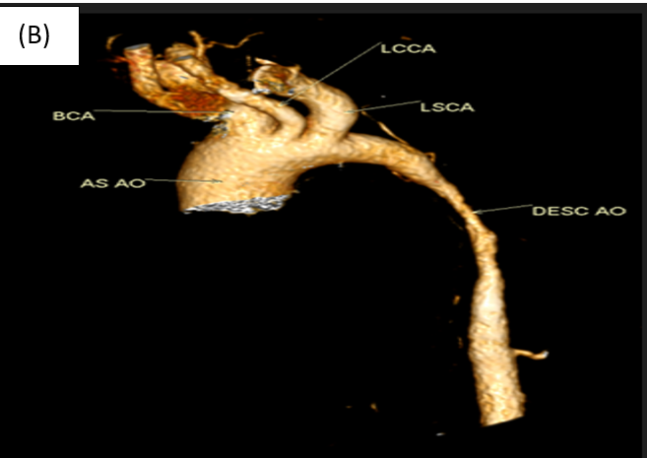
Case 1:
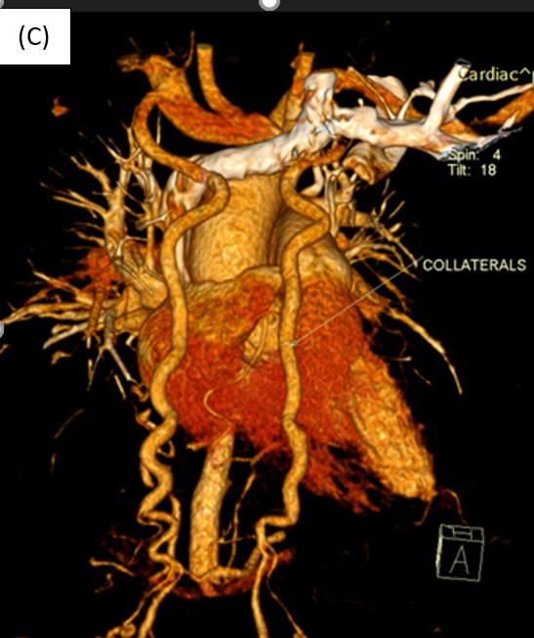
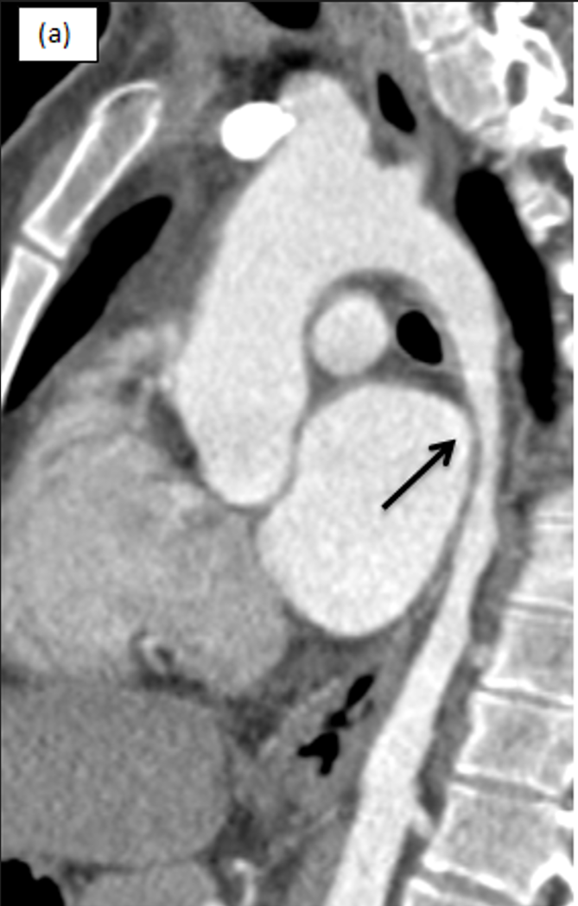

Fig3: Amale patient 3yrs old, cardiac CT shows: A&B: sagittal MIP &VR image of aortic arch &descending aorta show: A long segment of irregular stenosis of the descending thoracic aorta is seen showing marked luminal reduction(aortic hypoplasia), C:3D image shows: Extensive network of vascular collaterals (hypertrophied internal mammary arteries ,intercostal and prevertebral arteries) providing arterial supply to the lower body

Case 2:
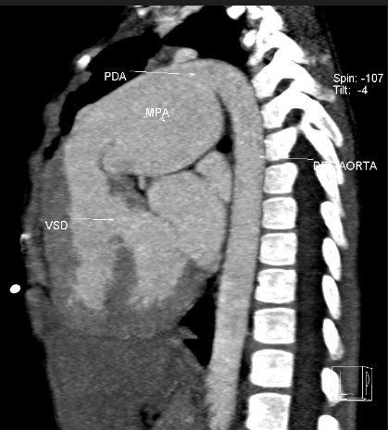
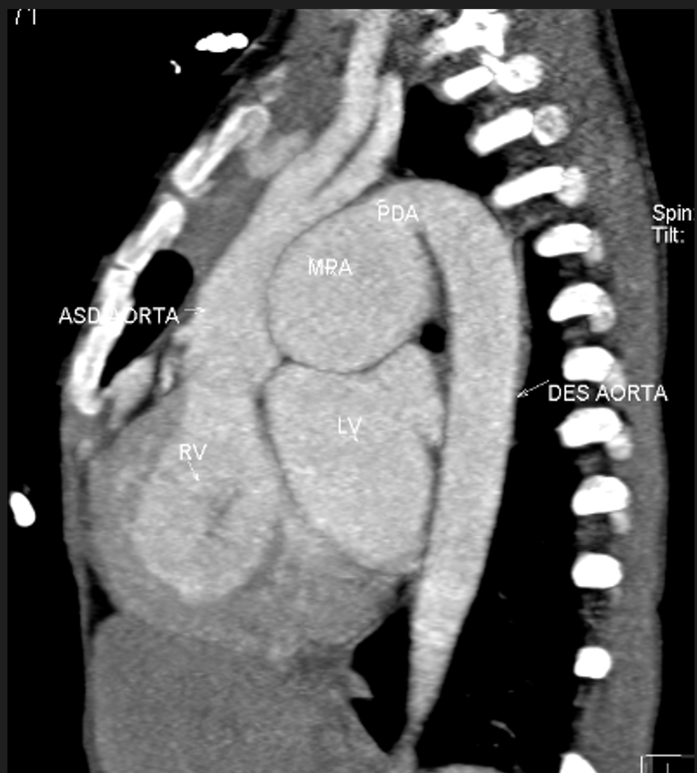
B
A

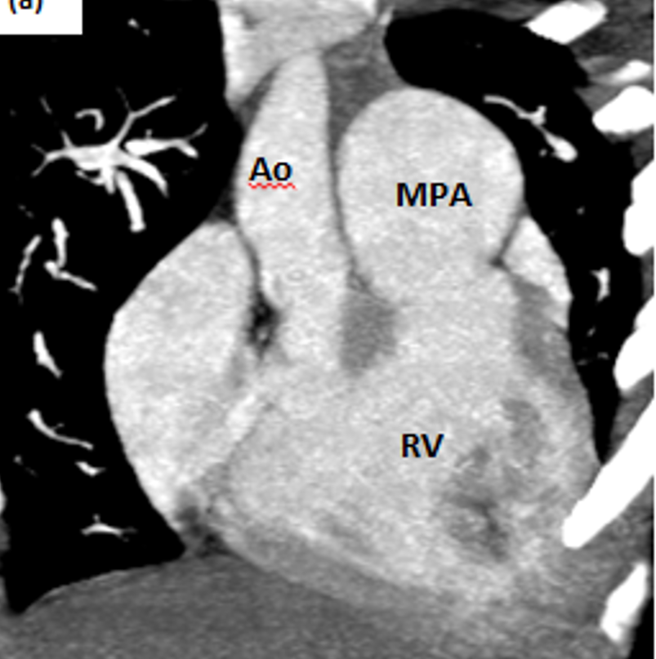
C

Fig4: A female patient 4yrs old,(Interrupted aortic arch type A),:A&B sagittal MIP images shows discontinuity between ascending and descending aorta distal to origin of left subclavian artery with the descending aorta is seen supplied by MPA via a large PDA (Ductus dependant circulation), the is also sub-membranous VSD noted in B image,C: shows both ascending aorta &MPA arising from right ventricle (DORV)

Case 3:
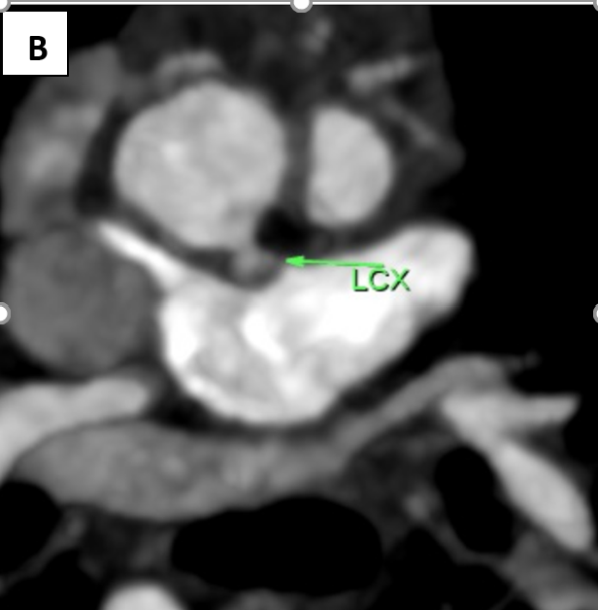
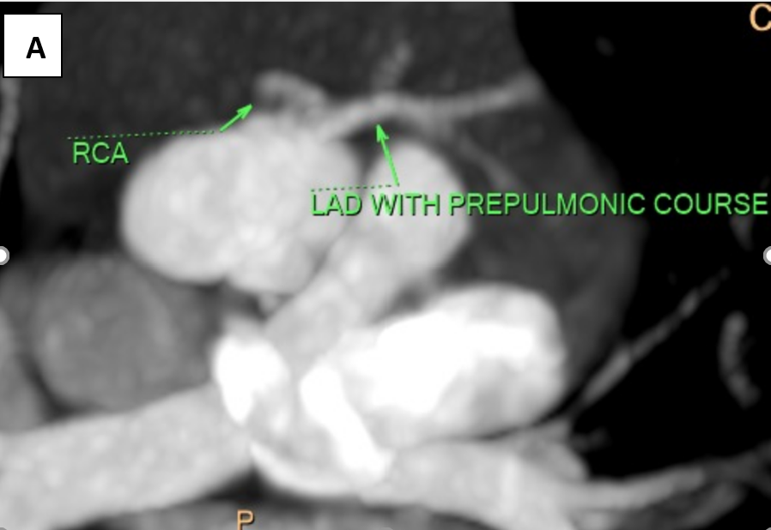

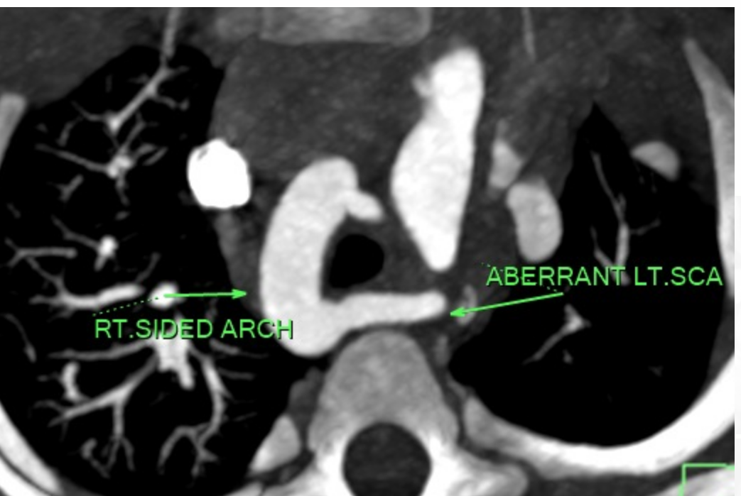
C

Fig5: a female patient 6months old, Multislice CT show A: common anomalies origin of LAD&RCA from right coronary sinus with anomalous pre-pulmonic course of LAD.B: normal origin of LCX from left coronary sinus C: right sided aortic arch with aberrant lt.SCA.

Discussion:

TTE is the first-line option for depicting complex CHD. Combined with Doppler flow imaging, TTE is preferred in the diagnosis of intracardiac anomalies. However, its small acoustic window, low spatial resolution, and operator-dependent nature are inherent limitations that affect its diagnostic performance in identifying extracardiac vascular anomalies. Although cardiac catheterization (CCA) has served as the gold standard for cardiac imaging with hemodynamic evaluation, its high radiation dose and catheter-related complications from its invasive nature are the major deterrents of using this tool . Magnetic resonance imaging (MRI) without X-ray exposure has been considered a promising imaging modality in recent years. Nevertheless, contraindications such as pacemakers, the need for lengthy sedation, and relatively lower spatial resolution limit the use of MRI in assessing the smaller extracardiac vascular deformities, particularly CAAs. DSCT, with its rapid acquisition speed, high spatial and temporal resolution, and powerful image post-processing techniques, is rapidly becoming one of the most valuable modalities for cardiovascular examination(5).

Recently, MSCT technology advancements implicating slip-ring gantry design, faster gantry rotation times, and, ultimately, multiple-row-detector arrays have paved the way for MDCT as a distinct diagnostic modality that is complementary to echocardiography and replacing further diagnostic cardiac catheterization for anatomical delineation if CT is employed with adequate contrast media opacification(6).

We agreed with(7,8) that MDCT is superior to ECHO in detecting extra-cardiac anomalies as those of coronary artery, pulmonary artery branches, and MAPCAs which is going with these study findings (7,8).

In addition, accurate preoperative detection of CAAs is essential for patients with TOF, because right ventriculotomy is required to relieve RVOT obstruction during the surgical correction of TOF. However, any major coronary artery that crosses the RVOT, such as the left anterior descending artery, could be accidentally damaged during the surgery. Our results showed that DSCT can detect this disorder in TOF patients with 100% sensitivity and 100% specificity, which is in agreement with the results of a previous study. The relationship to great arteries, ostia number and location, and the length of the coronary arteries that can be seen and evaluated accurately through the analysis of axial and three-dimensional reconstructed images by DSCT. Preoperative DSCT may thus help to optimize the surgical procedure to preserve the anomalous artery and improve the patients’ outcomes(5)

It is common in literature that anomalies of the great vessels are more prevalent in patients with CHD than in normal population In our study, we observed that CHD are commonly associated with extracardiac abnormalities, of which vascular anomalies were the commonest. (4),
The most common association observed in our study was between the aortic anomalies and conotruncal anomalies. Also venous anomalies were coincident with septal, conotruncal and heterotaxy anomalies (4)

The most common vascular anomalies observed in our study were PDA (20%) this in some disagreement with (4)who found the aortic anomalies were the most common observed anomalies

This study is limited by relatively small number of cases; similar studies on larger number of patients are required,secondaly high dose of radiation exposure to patients.

Conclusion: Multislice CT angiography (MSCTA) is helpful in accurate diagnosis of confident diagnosis and anatomic detection of extra-cardiac vascular abnormalities and coronary arteries anomalous origin compared with echocardiography.

References:
1-Öztürk, E., Tanıdır, İ. C., Kamalı, H., Ayyıldız, P., Topel, C., Onan, İ. S., ... & Güzeltaş, A. (2021). Comparison of echocardiography and 320-row multidetector computed tomography for the diagnosis of congenital heart disease in children. Revista Portuguesa de Cardiologia (English Edition), 40(8), 583-590.
2-Ramesh, M., & Balaji, S. (2021). Role of 128 Slice Computed Tomography Cardiac Angiography in the Diagnosis of Extra Cardiac Malformations of Congenital Heart Disease in Pediatric Age Group. International Journal Of Scientific Study, 9(3), 114-118.

3-Alsalihi, T. J., Malak, S., & Halim, N. N. (2018). Congenital extra-cardiac vascular anomalies as detected on multislice computed tomography angiography. The Egyptian Journal of Hospital Medicine, 70(4), 682-698.‏

4-Kamal, D. W., Abdelhameed, A. M., Mohammad, S. A., & Abbas, S. N. (2021). CT of cardiac and extracardiac vascular anomalies: embryological implications. Egyptian Journal of Radiology and Nuclear Medicine, 52, 1-11.‏

5-Hu, B. Y., Shi, K., Deng, Y. P., Diao, K. Y., Xu, H. Y., Li, R., ... & Guo, Y. K. (2017). Assessment of tetralogy of Fallot–associated congenital extracardiac vascular anomalies in pediatric patients using low-dose dual-source computed tomography. BMC cardiovascular disorders, 17, 1-8.‏
6-Alsalihi, T. J., Malak, S., & Halim, N. N. (2018). Congenital extra-cardiac vascular anomalies as detected on multislice computed tomography angiography. The Egyptian Journal of Hospital Medicine, 70(4), 682-698.

7-Elshimy, A., Khattab, R. T., & Hassan, H. G. E. M. A. (2021). The role of MDCT in the assessment of cardiac and extra-cardiac vascular defects among Egyptian children with tetralogy of Fallot and its surgical implementation. Egyptian Journal of Radiology and Nuclear Medicine, 52, 1-9.
8-Abd El-Rahman, H. M., Hassan, T. A., Elfawal, M. M., Hassan, B. A., & Abdel-Rahman, H. M. (2017). Role of 128 slice MSCT angiography in evaluation of congenital extra-cardiac intra-thoracic vascular anomalies in children. The Egyptian Journal of Radiology and Nuclear Medicine, 48(3), 581-591.‏

